**Screenshots of Working Model**

1. Adding name and contact number

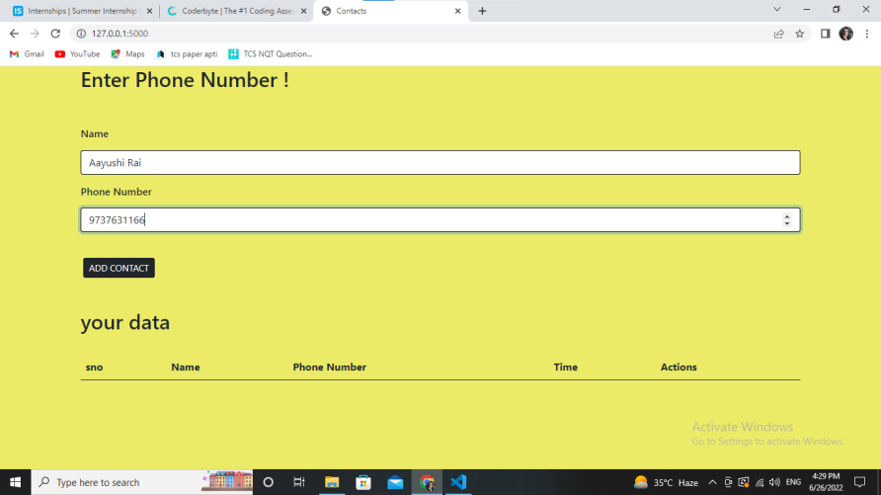

1. Reading the contact.

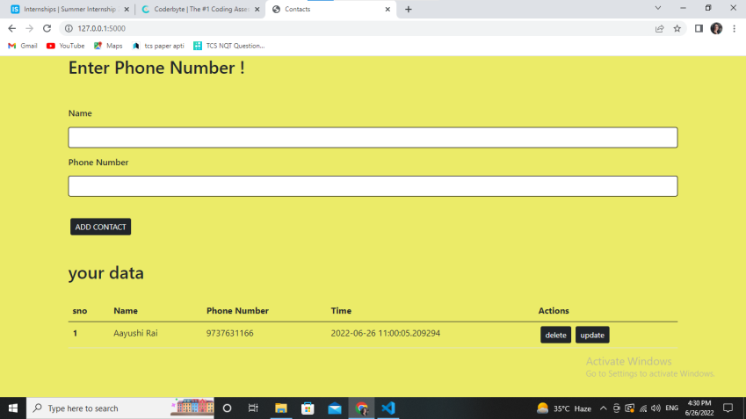

1. Updating the contact detail.

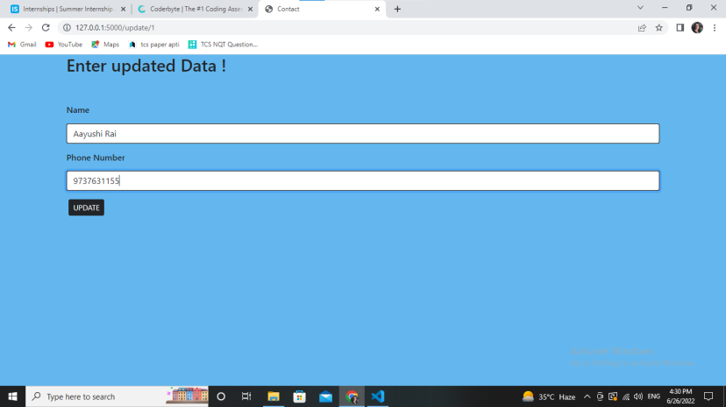

1. Contact detail updated.

